Dental/Medical Appointment Advocacy and Support Procedures

LIVEfree PROJECT workers are a representation of our organisation and must therefore represent the mission and values (see website for details) of our organisation well and with integrity at all times. LIVEfree PROJECT is a relationship-oriented service that cares holistically for vulnerable persons and families, everything we do is underpinned by our vision to strengthen, nurture and connect others. This means that when we are supporting clients at appointments, we are to be building appropriate relationship with them, listening to their story, assisting them in caring for themselves by advocating, transporting and supporting them at appointments and connecting them to any other support they may need.

Organisation of appointment
- If a client requires appointment assistance and needs support & advocacy in the organisation/transportation /attendance of this appointment, they first need to complete a LIVEfree PROJECT Support Agreement Form and an Authorisation for Dental and Medical assistance form – These are to be updated annually by clients. A copy of these forms can be found in the filing cabinet.
- LIVEfree PROJECT workers are to encourage and empower clients to make appointments for themselves wherever possible. If the client is not able to do so (e.g. because they’re a minor or not in an emotionally well state), LIVEfree PROJECT workers are to ask the client if they can make the appointment together or make the appointment on the client’s behalf, once the paperwork mentioned above has been completed and received.
- When booking dental appointments:

Children – Dr Joel at Adamstown No Gap Smiles Dental Surgery, 557 Glebe Rd, Adamstown. Ph: (02) 4957 1888.
Adults – NSW Dental, Level 2, 670 Hunter St, Newcastle West NSW 2302.
Ph: 1300 651 625.
- When booking eye tests:
Specsavers Jesmond, Jesmond Shopping Centre, 004/28 Blue Gum Rd, Jesmond NSW. Ph: 49516279. From 2020-2022, this store participates in the Vision Australia Spectacles program which provides significant discounts for people on Centrelink with assets under $500.
- LIVEfree PROJECT workers are to inform the client of the time/date of their appointment when the appointment is initially made. Always call the client for the first appointment, to talk through the process and allow them to ask questions. If it’s a follow up appointment it’s appropriate to text the client to remind them of it instead of calling them each time.
- Discuss transport to the appointment with the client, if they’re in need of transport, arrange pick up/drop off times with them (All LFP Workers are required to have a valid unrestricted driver’s license and comprehensive car insurance if transporting clients).
- Remind the client of the appointment date and time you have agreed upon to transport them a few days prior to the appointment via text message. If the client is a minor, inform their parents or carers. If you’re picking the child up from school, the parent or carer needs to inform the school and provide their permission of this a day prior to the appointment.
- When booking school children in for dental appointments, do not book more than two children in together at a time and allow approx. 1hr for one child and 1-2hrs for 2 children.

Appointment
- LIVEfree PROJECT workers are to wear badges that clearly identify who they are at all times.
- When assisting clients with their appointments ensure that you are punctual and organised with the correct paperwork and client details. Always bring the client’s Authorisation for Dental and Medical assistance form with you as it has all the client information, you’ll need for the appointment e.g. Their Medicare details.
- Transport:
- Ensure you drive in a safe manner and adhere to the NSW current road safety laws and regulations
- When transporting children, be aware of adhere to National Child Restraint Laws - see infographic below for outline and this website for more detailed information (https://roadsafety.transport.nsw.gov.au/stayingsafe/children/childcarseats/index.html) . If you require a car seat for an appointment, LIVEfree PROJECT has both booster and child seats on site for employee use, please ask your supervisor.
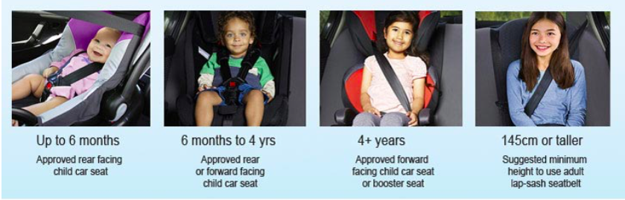

- Although a child is legally allowed to sit in the front seat between the ages of 7-16 years old, it is LIVEfree PROJECT’s policy that children are not able to sit in the front seat until they’re over the age of 12yrs old.
- Support during the appointment:
- When supporting a client at an appointment ensure you are engaged and actively listening to the service provider/health practitioner.
- If there is anything you don’t understand or are unsure about, ask the health professional to clarify, if you don’t understand it, it’s likely the client doesn’t either. Always ask the client if they have understood and if they have any questions.
- Take notes on the back of the client’s Authorisation for Dental and Medical assistance form of the treatment the client received, follow up appointments, prescriptions, referrals given and any other important information.
- Observe the client and their body language throughout the appointment to see if they need further support – encouragement, emotional support or a comforting hand where appropriate - particularly if it’s a difficult or painful appointment. e.g. during intense dental procedures or emotionally taxing Doctors’ appointments.
- If the client is referred elsewhere, ensure you have noted the details of this referral process. If a client is referred for an X-ray, take them for an X-ray whilst you’re with them at the local PRP.
- Expenditures:
- LIVEfree PROJECT strives to be a service that empowers others, including in their finances. If whilst out for an appointment a client needs a prescription or medication, discuss with them if they’re able to afford this. If they aren’t able to, offer to pay for it. This payment will be made using a LIVEfree PROJECT Visa debit card or using your own money, which you will then be reimbursed for (See supervisor for copy of reimbursement form).
- LIVEfree PROJECT Workers are to take clients out for a drink after appointments to debrief the appointment and discuss follow up support. This is always paid for by LIVEfree PROJECT as this is an important time for building relationship with our clients, valuing them, hearing their story and assessing if they need further support in any other areas.
- If the client is a child, part of the support is taking them to McDonalds afterwards, to provide them with a small treat (such as an ice cream or milkshake), for attending appointments that may be nerve-racking for children. This is an opportunity to listen the child, mentor and connect with them through conversation and placing value on them through this one-one time.
- Expenditures are to be kept to a minimum where possible, the budget for taking a client out after an appointment is approx. $10 per client.

Cancellations:
- In the client event that a client does not turn up for an appointment or is not home when you go to pick them up from home/school and you have attempted to get into contact with them to the best of your ability, reschedule their appointment or where possible give this appointment to another client.
- The LIVEfree PROJECT Support Agreement Form and Authorisation for Dental and Medical assistance form outlines that clients may be charged a cancellation fee by health professional/service if they cancel without 24hrs notice.

Documentation & follow up after an appointment:
All client appointments and interactions need to be recorded on paper and in our digital database:
- Clear notes regarding the appointment should be made on the back of the client’s Authorisation for Dental and Medical assistance form – including if there is a follow up appointment. Please date and sign your name at the bottom of your notes and file this document in our locked filing cabinet for the client’s privacy (See supervisor location of cabinet and key).
- Fill out the relevant information on our digital database as well – (See supervisor for access).
- If there are follow up appointments send the time/dates of these to the client and ensure you have a copy of this. If the client is a minor, ensure you pass all the important information regarding the appointment onto their parent/carer.
- Make any referrals necessary and document these in their file.

